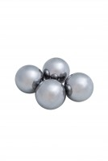 | Set of 12 Abrasive Charges (ASTM).  Code: 42-5300/10  Product Group: Los Angeles Abrasion Machine, Los Angeles Abrasion Machine  ASTM Set of 12.

Standards
EN 1097-2, ASTM C131, ASTM C535, AASHTO T96

