 | Proving Ring 10,000 lbf Capacity  Code: PR-100  Product Group: Marshall Stability Tester, Additional Analog Proving Rings

Spares/Consumables
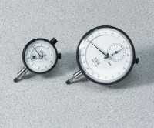 | Mechanical Dial Indicator - 0.2" Range  Code: 88-4000

