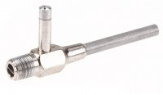 | Aspirator Type Filter Pump  Code: 45-9311  Product Group: Vacuum Pyknometer (2,000 Gram), Specific Gravity (Rice) Test with 2,000 gram Vacuum Pyknometer  The Aspirator Filter Pump used for high performance vacuum filtrations under both high and low water pressure conditions.

Further Information
Features a ball-type, positive-action valve in the suction tube which prevents water backflow if the pressure is reduced.

