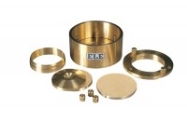 | 2.416" Fixed Ring Consolidometer  Code: 25-0480  Product Group: Fixed Ring Consolidation, Pneumatic Consolidation Apparatus, Table Top Consolidation Apparatus  With cutting (specimen) ring.

Standards
ASTM D2435, ASTM D4546, AASHTO T216

Specification
Application | California
Specimen Diameter | 2.41 6â
Specimen Area | 4.585inÂ²
Beam Ratio | 10:01
Load | 1.45 kg
Stress | 1000lbf/ftÂ²
Typical Maximum Stress | 11 0,720lbf/ftÂ²
Stress for 1 kg | 692lbf/ftÂ²

Spares/Consumables
Upper and Lower Porous Stones, 2.416"
Code: 25-0480/13

