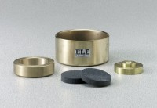 | Specimen Ring 2.5"  Code: 25-0533  Product Group: Floating Ring Consolidometer  For 2.5” (63 mm) diam.samples.

