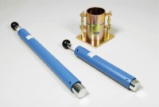 | BS Compaction Rammer 4.5Kg Wt.  Code: 24-9004  Product Group: BS/EN compaction test 4.5kg  50mm diameter with 450mm drop, manufactured from corrosion protected steel.

Standards
BS 1377-4, BS 1924-2, EN 1997-2

Specification
Rammer | 50 mm dia, 4.5 kg
Drop | 450 mm
Guide Sleeve | Machined steel tubing with air pressure release holes
Finish | Corrosion resistant
Weight kg | 7.5

