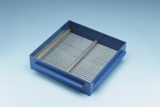 | Grid Sieve 2.5mm Slot Width for EN Aggregate Flakiness Test.  Code: 42-0300  Product Group: Grid Sieves  2.5mm

Standards
EN 933-3

Further Information
**NOT AVAILABLE FOR SALE IN THE USA**
Passing Size - 5 mm Retained Size - 4 mm

