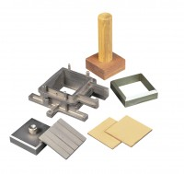 | Specimen Cutter 100mmsq.  Code: 26-2201  Product Group: Shear Box Assemblies, Shear Box Assemblies

Standards
ASTM D3080, AASHTO T236

Spares/Consumables
Specimen Cutter 2.5 Inch Diameter.
Code: 26-2217
Specimen Cutter 60mm Sq.
Code: 26-2185

