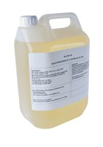 | Oil 5 Litres T46  Code: 26-1805  Product Group: Oil/Water Constant Pressure System  5 litres

