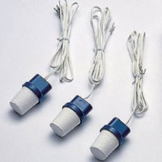 | Soil Moisture Block 4.5 m Lead  Code: 514-132  Product Group: Soil Moisture  4.5 Metre Long Lead

