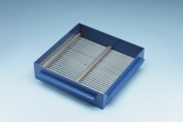 | Grid Sieve 12.5mm Slot Width for EN Aggregate Flakiness Test.  Code: 42-0316  Product Group: Grid Sieves  12.5mm

Standards
EN 933-3

Further Information
**NOT AVAILABLE FOR SALE IN THE USA**
Passing Size - 25 mm Retained Size - 20 mm

