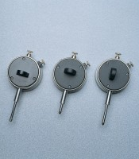 | Dial Gauge  Code: 83-5456  Product Group: Measurement of Horizontal and Vertical Movement, Dial Gauges

Specification
Diameter mm | 57
Travel mm | 10
Grad. Mm | 0.01
Scale | RH
Anvil | Ball
Back type | A

