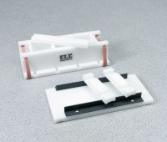 | Cement Cube Mould - Economy  Code: 39-0416  Product Group: Cement Cube Mould (Economy)

Specification
Construction | Ultra-high density molecular weight polyethylene; three gang; up to three 2â (50.8 mm) samples.
Top | Polyethylene with plastic guide rails.
Tamper | Polyethylene.
Weight | Net 2.4 lbs. (1.1 kg).

