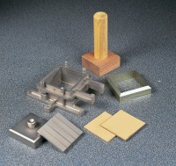 | Specimen Extrusion Tool 100 mm sq  Code: 26-2205  Product Group: Shear Box Assemblies

Standards
ASTM D3080, AASHTO T236

