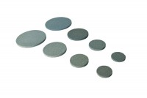 | Porous Disc 50mm Pack of 2  Code: 25-5561  Product Group: Accessories for CU/CU effective stress, Porous Stones  50 mm diameter porous disc (Pack Of 2).

