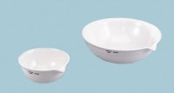 | Evaporating Dish - 120 ml Capacity  Code: 88-6710  Product Group: Evaporating Dishes  90 mm diam.; 120 ml capacity.

