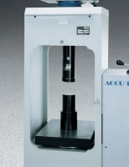 | Platen Set for 2" Cubes  Code: 37-5510  Product Group: Rapid-Change Cube Platen Sets, Accu-Tek Touch 350 Series, Accu-Tek Touch 500 Series

Standards
ASTM C109, ASTM C39, AASHTO T22

