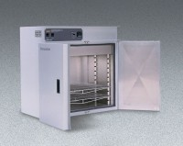 | Forced Convected Oven - 27 cu. ft. capacity - 240v  Code: 88-0166/01  Product Group: Forced Convected Ovens  240vAC, 50/60 Hz, 1ø, 16.4 amps.

