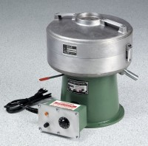 | Centrifuge Extractor 3,000 g  Code: 45-3825/02  Product Group: Asphalt Centrifuge Extractors

Standards
ASTM D2172, AASHTO T164

Further Information
120vAC, 60 Hz, 1ø.

Specification
Control | Variable speed, 0-3,600 rpm; brake for fast  stopping.
Motor | 1/6 h.p.
Cover | Aluminum; removable, with integral cup for  adding solvent.
Housing | Aluminum; removable, sealed.
Bowl | Aluminum; removable.
Filter Discs | 10 included.
Dimensions | 18â w. x 18â d. x 19â h.  (457 x 457 x 483 mm).
Weight | Net 140 lbs. (63.5 kg).

