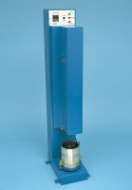 | Automatic Soils Compactor ASTM 220-240V 50Hz 1Ph.  Code: 24-9095/01  Product Group: Automatic Compactors, Automatic Soil Compactor

Standards
ASTM D558, ASTM D559, ASTM D560, ASTM D698, ASTM D1557, AASHTO T99, AASHTO T134, AASHTO T135, AASHTO T136, AASHTO T180

Specification
Hammer | Circular faced, 2.0” (50.8 mm) diam. foot; adjustable to either 5.5 lb.(2.5 kg) or 10 lb. (4.5 kg) weight.
Drop | Adjustable to either 12 ” (305 mm) or 18” (45 7 mm)
Controls | Digital counter system, selector switch for either standard proctor test or modified proctor/CBR testing.
Dimensions | 10” w. x 17” d. x 55 ” h. (25 0 x 43 0 x 1,400 mm).
Weight | Net 41 9 lbs. (190 kg).

Spares/Consumables
 | Lead Cylinders  Code: 24-9095/13
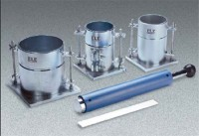 | Modified Compaction Mould  Code: 24-9098
Standard Compaction Mould
Code: 24-9097

