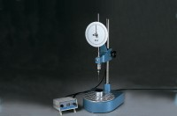 | Semi-Automatic Penetrometer  Code: 46-5295/01  Product Group: Penetration Test  As 46-5290 but incorporates Digital Automatic Controller which releases the needle assembly. The time set is displayed by a bright, easy to read display.

Standards
BS 2000-49, EN 1426, EN 13179-2, ASTM D5, AASHTO T49, IP 49

Further Information
**NOT AVAILABLE FOR SALE IN THE USA**

