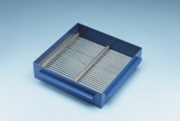 | Grid Sieve 10mm Slot Width for EN Aggregate Flakiness Test.  Code: 42-0314  Product Group: Grid Sieves  10mm

Standards
EN 933-3

Further Information
**NOT AVAILABLE FOR SALE IN THE USA**
Passing Size - 20 mm Retained Size - 16 mm

