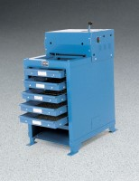 | Aggregate Screen Shaker - Hydraulic Operation 115vAC  Code: 80-0405/02  Product Group: Aggregate Screen Shakers

Specification
Capacity | 1 cu. ft. (0.03 m3).
Motor | Capacitor-type; 1/3 h.p. with overload protection.
Tray Dimensions | Screen Area: 14 -3/4â x 22 -3/4â (375 x 578 mm).  Overall: 18â x 26â (45 7 x 660 mm).
Trays | Steel wire cloth; five included: 2â, 1-1/2â, 1â, 3/4â,  1/2â plus dustpan tray.
Overall Dimensions | 23â w. x 31â d. x 43â h. (584 x 787 x 1,092 mm).
Weight | Shpg. 500 lbs. (22 7 kg).

