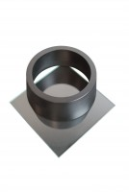 | EN Vicat Mould  Code: 38-2300  Product Group: Vicat Method, Automatic Vicat  Accessory: manufactured from a hard rubber compound and supplied complete with a glass base plate.

Standards
EN 196-3

Further Information
**NOT AVAILABLE FOR SALE IN THE USA**

Spares/Consumables
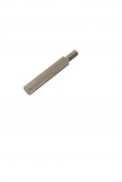 | Consistency Plunger  Code: 38-2010/10

