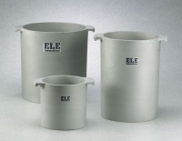 | Unit Weight Measure 1/3 cu. Ft. Capacity  Code: 34-2852  Product Group: Unit Weight Measures, Unit Weight Measures  1/3 cu. Ft. Capacity

Standards
ASTM C29

Specification
Construction | Cast aluminum; machined inside; with handles.
Top Rim | Machined smooth; parallel with bottom.
Inner Dimensions | 8â (203 mm) i.d. x 11 .5â  (292.1 mm) inside h.
Weights | Net 15 -1/4 lbs. (6.9 kg).

