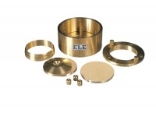 | 2.5 Inch Dia Upper and Lower Porous Stones for Use on EL25-0479 Series Cell.  Code: 25-0479/13  Product Group: ASTM/AASHTO consolidation cells and accessories, Fixed Ring Consolidation

Standards
ASTM D2435, ASTM D4546, AASHTO T216

