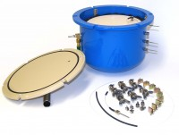 | 5-Bar Pressure Plate Extractor.  Code: 532-100  Product Group: Pressure plate extractors  Supplied without ceramic plate cells

Spares/Consumables
 | O-Ring Lid Seal Pack of 2  Code: 532-100/10

