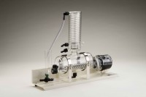 | Distilled Water Still  Code: 82-8020/01  Product Group: Distilled Water Still

Further Information
**NOT AVAILABLE FOR SALE IN THE USA**

Specification
Dimensions (l x w x h) | 590 x 530 x 940 mm
Boiling chamber | Glass
Condenser | Borosilicate glass
Output | 3.5 litres/hr when permanently connected to water supply
Electrical supply | 220 – 240 V AC, 50 - 60 Hz, 1 ph
Rated power | 2.75 kW
Weight | 12 kg

