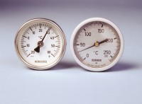 | Portable Thermometer 100 ml  Code: 82-5247  Product Group: Portable Dial-type Thermometers  50 mm diameter dial with a 180 mm long stem.

Further Information
**NOT AVAILABLE FOR SALE IN THE USA**

