Slump Cones
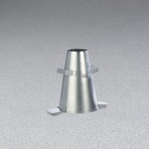 | Metal Slump Cone - English  Code: 34-0108  Attributes: Weight, lbs = 5.5, Description = Metal Slump Cone - English  Standards: ASTM C143, ASTM C192, AASHTO T23, AASHTO T119, ASTM T126

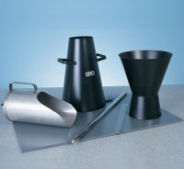 | Slump Cone  Code: 34-0110  Attributes: Description = Slump Cone, Weight, kg = 1.3 kg, Weight, lbs = 5.5  Standards: ASTM C143, ASTM C192, AASHTO T23, AASHTO T119, ASTM T126

 | Graduated Tamping Rod  Code: 34-0132  Attributes: Description = Tamping Rod 5/8" Diameter, Dimensions, diameter x length, ” = 5/8 x 24  Standards: ASTM C31, ASTM C124, ASTM C138, ASTM C143, ASTM C157, ASTM C192, ASTM C232, ASTM C234, AASHTO T23, AASHTO T119, AASHTO T120, AASHTO T121, ASTM T126, AASHTO T158, AASHTO T159, AASHTO T160

Slump Cone Base
Code: 34-0150
Attributes: Dimensions width x length, ” = 15 x 15, Description = Slump Cone Base
Standards: ASTM C143, ASTM C192, AASHTO T23, AASHTO T119, ASTM T126

Cement Pan
Code: 34-0152
Attributes: Dimensions, l x w x h, ” = 24x24x3, Description = Cement Pan
Standards: ASTM C143, ASTM C192, AASHTO T23, AASHTO T119, ASTM T126

Slump Cone Funnel
Code: 34-0180
Attributes: Description = Slump Cone Funnel, Weight, kg = 1.3 kg, Base Dimensions l x w x h, ” = 208.59
Standards: ASTM C143, ASTM C192, AASHTO T23, AASHTO T119, ASTM T126

