Sieve Lids and Receivers ASTM
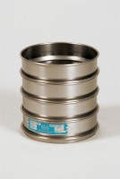 | 8 Inch Dia Lid.  Code: 79-5400  Attributes: Sieve Type = Lid  Standards: ASTM E11

8in Dia Receiver.
Code: 79-5410
Attributes: Sieve Type = Receiver
Standards: ASTM E11

12in Dia Lid ASTM.
Code: 79-6150
Attributes: Sieve Type = Lid
Standards: ASTM E11

12in Dia Receiver ASTM.
Code: 79-6160
Attributes: Sieve Type = Receiver
Standards: ASTM E11

