Laboratory Concrete Mixer
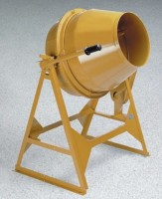 | Laboratory Concrete Mixer  Code: 34-3592/02  Attributes: Dimensions, l x w x h, ” = 41 x 26 x 55, Description = Laboratory Concrete Mixer  Standards:

