Proctor compaction
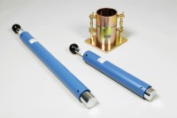 | Straight Edge 300mm.  Code: 24-9010  Attributes: Description = 300 mm straight edge  Standards: BS 1377-4, BS 1924-2, EN 1997-2, ASTM D698, ASTM D1557, AASHTO T99

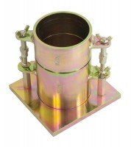 | Proctor Mould 1/30 Ft3.  Code: 24-9060  Attributes: Description = Proctor mould, Guide Sleeve = Steel  Standards: ASTM D558, ASTM D559, ASTM D560, ASTM D698, ASTM D1557, AASHTO T99, AASHTO T134, AASHTO T135, AASHTO T136, AASHTO T180

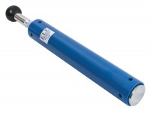 | ASTM Compaction Rammer 2.5Kg.  Code: 24-9063  Attributes: Description = Proctor compaction rammer  Standards: ASTM D558, ASTM D559, ASTM D560, ASTM D698, AASHTO T99, AASHTO T134, AASHTO T135, AASHTO T136

