Hydrometer Jar Bath
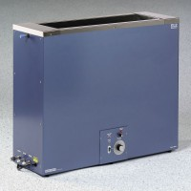 | Hydrometer Jar Bath 110vAC  Code: 24-4867/02  Attributes: Plumbing Ports = Overflow; Drain; Inflow and outflow for cooling<br>system., Description = Hydrometer Jar Bath 110vAC  Standards: ASTM D422, AASHTO T88

Hydrometer Jar Bath 220vAC
Code: 24-4867/01
Attributes: Plumbing Ports = Overflow; Drain; Inflow and outflow for cooling<br>system., Description = Hydrometer Jar Bath 220vAC
Standards: ASTM D422, AASHTO T88

