Expansion (swell) Test Equipment
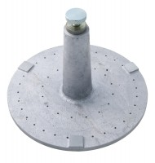 | Swell Plate  Code: 24-9260  Attributes: Description = Swell plate, Contact Head = Adjustable; locks on stem with knurled nut.  Standards: ASTM D1883, AASHTO T193

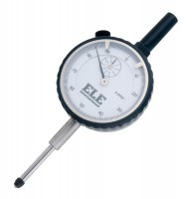 | Penetration/Swell Dial Gauge ASTM.  Code: 24-9184  Attributes: Description = Penetration/swell gauge ASTM  Standards:

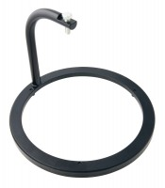 | Swell Tripod  Code: 24-9262  Attributes: Description = Swell tripod, Clamp = Integral part of assembly; holds dial indicator.  Standards: ASTM D1883, AASHTO T193

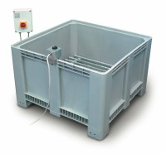 | Large Curing Tank C/W with Circulating Pump Heater/Thermostat Unit and Lower Rack  Code: 34-6575/01  Attributes: Description = Curing/soaking tank  Standards:

 | Dial Gauge 25mm Travel X 0.01mm Divisions.  Code: 24-9275  Attributes: Description = Penetration/swell gauge BS  Standards:

