Vacuum Pyknometer
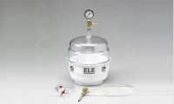 | Vacuum Pyknometer, 6000 g  Code: 45-9300  Attributes: Description = Vacuum Pyknometer (6,000 gram)  Standards: EN 12697-5, ASTM D2041, AASHTO T209, AASHTO T283

 | Vacuum Pyknometer Apparatus  Code: 45-9305/01  Attributes: Description = Vacuum Pyknometer Apparatus, Power Supply = 220 - 240 V AC, 50 Hz, 1 ph  Standards: EN 12697-5

