Digital Pocket Thermometer
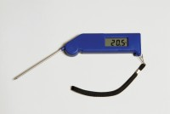 | Digital Pocket Thermometer  Code: 82-5420  Attributes: Temperature Range °C = -49.9 to +199.9  Standards:

