Glass Graduated Cylinders
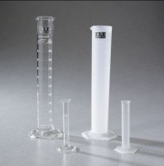 | Glass Graduated Cylinder - 10 ml Capacity  Code: 88-6000  Attributes: Liquid Capacity, ml = 10, Description = Glass Graduated Cylinder - 10 ml Capacity  Standards:

Glass Graduated Cylinder - 25 ml Capacity
Code: 88-6002A
Attributes: Liquid Capacity, ml = 25, Description = Glass Graduated Cylinder - 25 ml Capacity
Standards:

Glass Graduated Cylinder - 50 ml Capacity
Code: 88-6004
Attributes: Liquid Capacity, ml = 50, Description = Glass Graduated Cylinder - 50 ml Capacity
Standards:

Glass Graduated Cylinder - 100 ml Capacity
Code: 88-6007
Attributes: Liquid Capacity, ml = 100, Description = Glass Graduated Cylinder - 100 ml Capacity
Standards:

Glass Graduated Cylinder - 500 ml Capacity
Code: 88-6010
Attributes: Liquid Capacity, ml = 500, Description = Glass Graduated Cylinder - 500 ml Capacity
Standards:

Graduated Cylinder
Code: 88-6012
Attributes: Description = Glass Graduated Cylinder - 1 Litre Capacity
Standards:

