Constant Head Apparatus
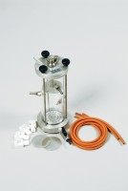 | Constant Head Permeability Cell 75mm Diameter Specimen.  Code: 25-0580  Attributes: Description = Constant head permeability cell, End Plates = Aluminium  Standards: BS 1377, EN 1997-2, ASTM D2434, AASHTO T215

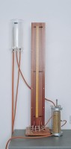 | Manometer Tubes & Stand.  Code: 25-0591  Attributes: Description = Manometer tubes & stand, Weight, kg = 2.8  Standards: BS 1377, EN 1997-2, ASTM D2434, AASHTO T215

Constant Level Tank.
Code: 25-0593
Attributes: Description = Constant level tank, Weight, kg = 2.4
Standards: BS 1377, EN 1997-2, ASTM D2434, AASHTO T215

