Benkelman Beam
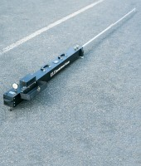 | Benkelman Beam  Code: 47-1460  Attributes: Description = Benkelman Beam, Open Length, ft. = 12  Standards: AASHTO T256

 | Vertical Dial Indicator 1" range x 0.002" divisions  Code: 47-1460/12  Attributes: Description = Vertical Dial Indicator 1″ range x 0.002″ divisions  Standards:

Vertical Dial Indicator 25 mm range x 0.02 mm divisions
Code: 47-1460/14
Attributes: Description = Vertical Dial Indicator 25 mm range x 0.02 mm divisions
Standards:

