Constant Head Sand/Gravel Permeameters
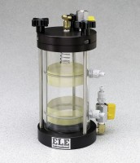 | Constant Head Sand/Gravel Permeameters  Code: 25-0562  Attributes: Clamping Rods = Three; quick release type., Description = Constant Head Sand/Gravel Permeameters  Standards: ASTM D2434

 | Wall Mounted Manometer Panel  Code: 25-0567  Attributes: Flow Tubes = Acrylic; each with its own flow control valve., Description = Wall Mounted Manometer Panel  Standards: ASTM D2434

Constant Head Tank System
Code: 25-0568
Attributes: Tank Capacity, cc = 1000, Description = Constant Head Tank System
Standards: ASTM D2434

