Kelly Ball Apparatus
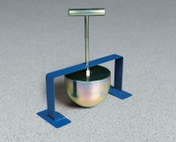 | Kelly Ball Apparatus  Code: 34-0952  Attributes: Handle = 5” x 1/4” graduations; threads into weight., Description = Kelly Ball Apparatus  Standards: CTM 533

