Aggregate Scoop Pan
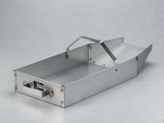 | Aggregate Scoop Pan  Code: 23-3390  Attributes: Construction = 18 gauge stainless steel; one fixed and one bail handle., Description = Aggregate Scoop Pan  Standards:

