Hotplate
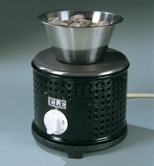 | Hotplate  Code: 78-2950/01  Attributes: Voltage Supply = 220 - 240 V AC, 50/60 Hz  Standards:

