Paqualab Test Meters
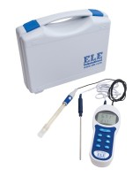 | Digital Ph/Temp/Mv Meter. with Electodes Carrying Case and Ph Buffers.  Code: 430-020  Attributes: Description = Digital Ph/Temp/Mv Meter  Standards:

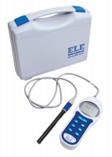 | Conductivity/Temp/Tds Meter with Electrode and Carrying Case  Code: 513-160  Attributes: Description = Conductivity/Temp/TDS Meter  Standards:

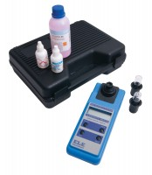 | Dissolved Oxygen / Temp Meter. with Electrode and Carrying Case  Code: 521-050  Attributes: Description = Dissolved Oxygen/Temp Meter  Standards:

 | Turbidity Meter. Range 0-1000 Ftu. Supplied with Carrying Case Batteries and Calibration Solutions  Code: 430-260  Attributes: Description = Turbidity Meter  Standards:

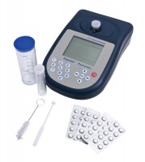 | Paqualab Photometer Complete with Six Test Tubes Dilution Tube Operating Manual and Carrying Case.  Code: 430-550  Attributes: Description = Photometer  Standards:

Standard Colour Comparator Kit In Carrying Case. Supplied Without Colour Disks and Reagents.
Code: 432-020
Attributes: Description = Comparator Kit
Standards:

Water Test Kit. Includes Tests for Ph Chloride Total Hardness and Iron.
Code: 521-080
Attributes: Description = Water Test Kit
Standards:

