Swell Plate
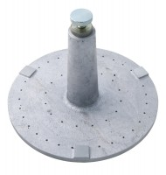 | Swell Plate  Code: 24-9260  Attributes: Description = Swell plate, Contact Head = Adjustable; locks on stem with knurled nut.  Standards: ASTM D1883, AASHTO T193

