Organic Impurities Test
 | Round Graduated Bottle  Code: 42-3000A  Attributes: Cap = Plastic; screw-on., Description = Round Graduated Bottle  Standards: ASTM C40, AASHTO T21

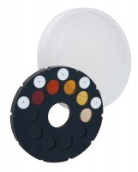 | Colour Standard to ASTM C40  Code: 42-3040  Attributes: Description = Colour Standard, Colour Standards = Five, on non-fading glass.  Standards: ASTM C40, AASHTO T21

Sodium Hydroxide Solution
Code: 42-3050
Attributes: Solution = 3% sodium hydroxide; 97% water; one pint<br>plastic bottle., Description = Sodium Hydroxide Solution
Standards: ASTM C40, AASHTO T21

