Moulding of 50 mm and 100 mm Specimens
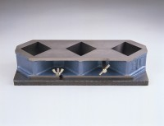 | Three-gang Mould  Code: 39-0410  Attributes: Description = Three-gang Mould, Weight, kg = 6.5  Standards: BS 1881-131, ASTM C109

