Pocket Penetrometer
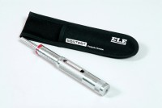 | Pocket Penetrometer.  Code: 29-3729  Attributes: Description = Pocket Penetrometer, Dimensions, diameter x length, ” = 3/4 x 6-3/8  Standards:

 | Adaptor Foot  Code: 29-3729/10  Attributes: Dimensions w x d x h, ” = 22x22x20 mm, Description = Adaptor Foot  Standards:

