Double Ring Infiltrometer
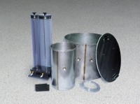 | Double Ring Infiltrometer  Code: 25-0660  Attributes: Mariotte Tubes = Graduated; two included; 3,000 ml and<br>10,000 ml capacities., Description = Double Ring Infiltrometer  Standards: ASTM D3385

